# Swanage Medical Practice

|  |  |  |
| --- | --- | --- |
| DR. WENDY HEARD  DR. CLAIRE HOMBERSLEY  DR. KATIE EVANS  DR. MARK LAW  DR. KIRAN QURESHI  DR. ANDREW MCINTOSH  DR. BETH LAW (Salaried GP)  DR. VANESSA MULHOLLAND (Salaried GP)  PRACTICE MANAGER: MISS NATASHA RITCHIE |  | THE HEALTH CENTRE  STATION APPROACH  SWANAGE  DORSET  BH19 1HB  Tel. 01929 422231 |

To Whom It May Concern

Dear Patient,

Thank you for choosing to register with us at Swanage Medical Practice.

To enable us to process your registration, please will you complete **ALL** sections of the attached registration form.

If you wish to decline some areas, please tick the declined box. However, completing each section fully may help with your healthcare.

You will also need to provide identification, which should be a combination of:

* Photo ID, such as Passport or Drivers Licence
* Birth or Marriage Certificate
* Something with your address on: utility bill, council tax bill, credit card/bank statements

We also need:

* **Your NHS Number – this is essential**

An electronic copy of our Practice Booklet, which gives full information about our services, and our latest Newsletter can be found on line at **ww.swanagemedical.org.uk**. (Paper copies can be requested if required).

Once you have returned the registration form in person, with your ID papers, we will endeavour to register you on our system within 7 working days.

Yours faithfully,

***Swanage Medical Practice***

|  |  |
| --- | --- |
| **ETHNIC ORIGIN** White, British - **A**  White Irish - **B**  Any other white background - **C**  White & black Caribbean, mixed - **D**  White & black African, mixed - **E**  White & Asian, mixed - **F**  Any other mixed background - **G**  Asian/Asian British, Indian - **H**  Asian/Asian British, Pakistani - **J**  Asian/Asian British, Bangladeshi - **K**  Any other Asian background - **L**  Black/black British, Caribbean - **M**  Black/black British, African - **N**  Any other black background - **P**  Chinese - **R**  Any other ethnic group - **S** | **Please circle or write below the appropriate letter to indicate your ethnic origin.**  **I wish to decline the ethnicity questionnaire (Code:9SD)** |

|  |  |
| --- | --- |
| **First Language Spoken:** | **I wish to decline the First Language Spoken question (Code:13ZG)** |

|  |  |
| --- | --- |
| Patient informed of their named accountable GP (XacWQ) |  |

|  |  |
| --- | --- |
| Patient informed of their named accountable GP (Xab9D) |  |

**REGISTRATION FORM**

**Please write clearly in capitals & complete ALL relevant boxes**

|  |  |
| --- | --- |
| Title |  |
| Surname |  |
| First Name(s) |  |
| Previous Surname(s) |  |
| Date of Birth |  |
| Precise Town, County & Country Of Birth |  |
| Male or Female |  |
| Home Address |  |
| Postcode |  |
| Telephone Number |  |
| Mobile Number |  |
| Your email address |  |
| **NHS Number** (**ESSENTIAL & can be obtained from your previous surgery**) |  |
| **PLEASE HELP US TRACE YOUR PREVIOUS MEDICAL RECORDS BY PROVIDING THE FOLLOWING INFORMATION:** | |
| Your previous address in UK, **including postcode** |  |
| Name of Doctor while at this Address |  |
| Address of previous Doctor |  |
| **IF YOU ARE FROM ABROAD** |  |
| Your first UK address where registered with a GP, **including postcode** |  |
| Date you first came to live in UK |  |
| Date you expect to be leaving UK (if known) |  |
| If previously resident in UK, date of leaving |  |
| **IF YOU ARE RETURNING FROM THE ARMED FORCES** | |
| Address before enlisting, **including postcode** |  |
| Service or Personnel Number |  |
| Enlistment Date |  |
| Discharge Date |  |

**Signature……………………………………………………………Date………………………**

**PATIENT DECLARATION FOR ALL PATIENTS WHO ARE NOT ORDINARLY RESIDENT IN THE UK**

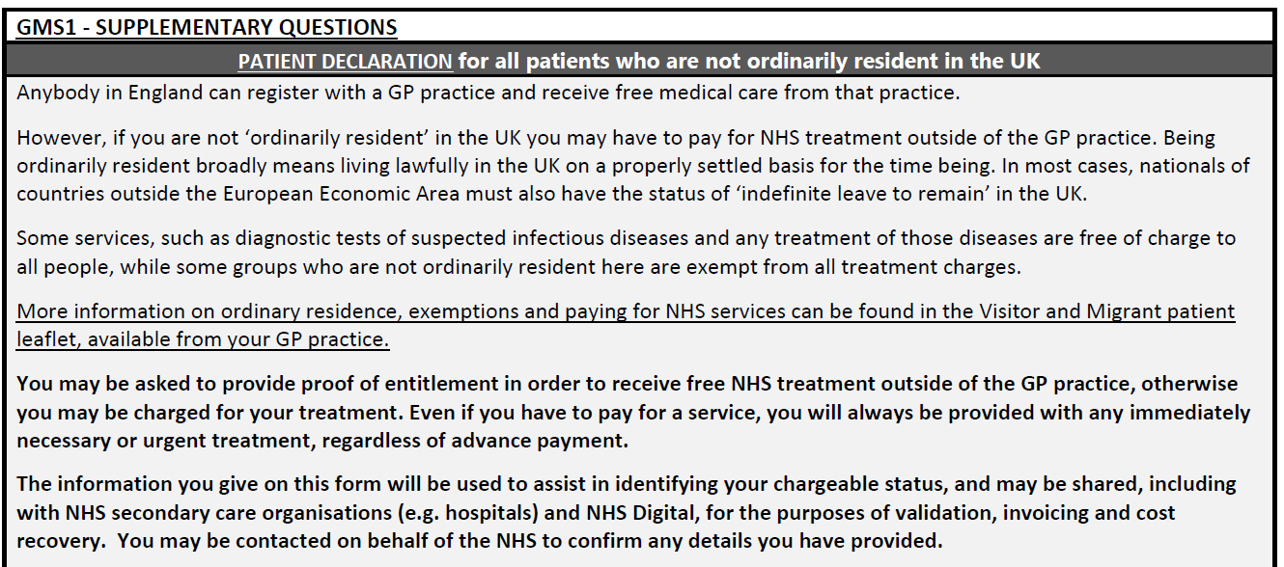

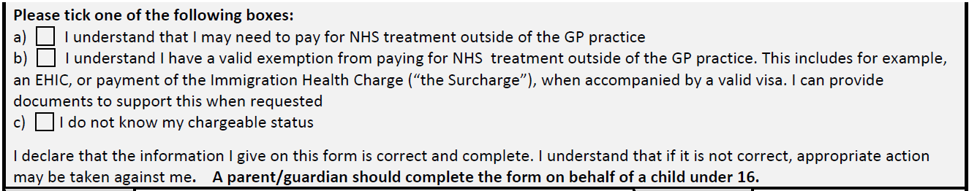





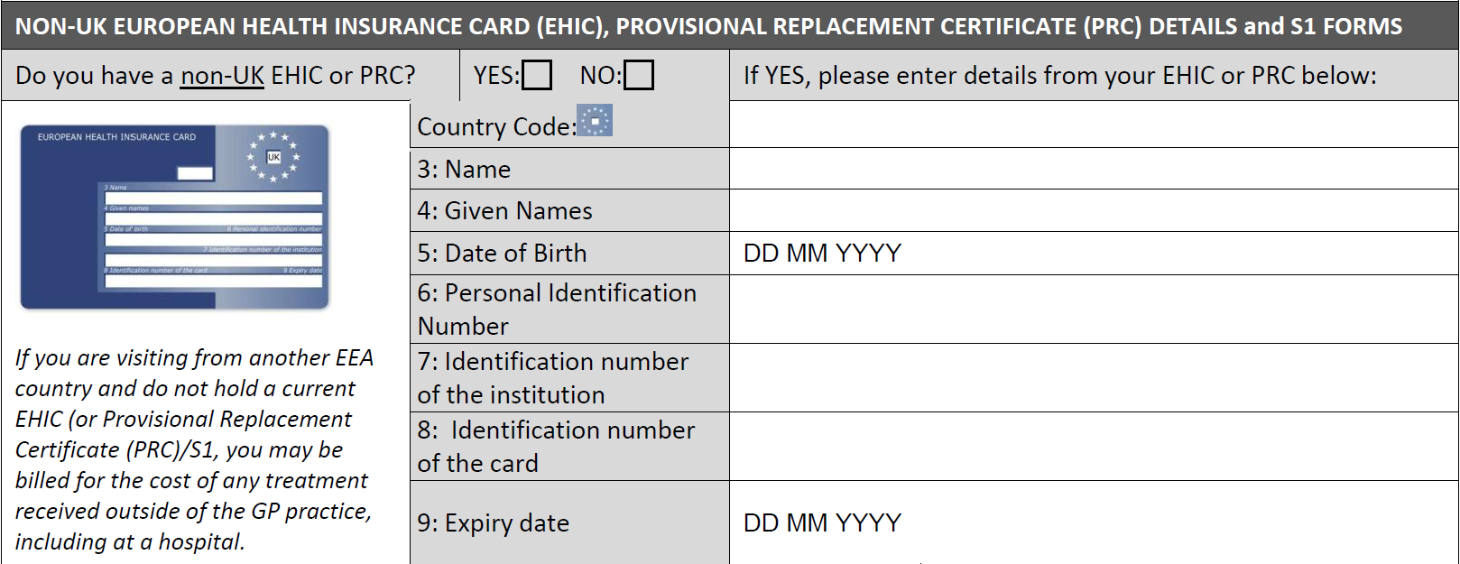

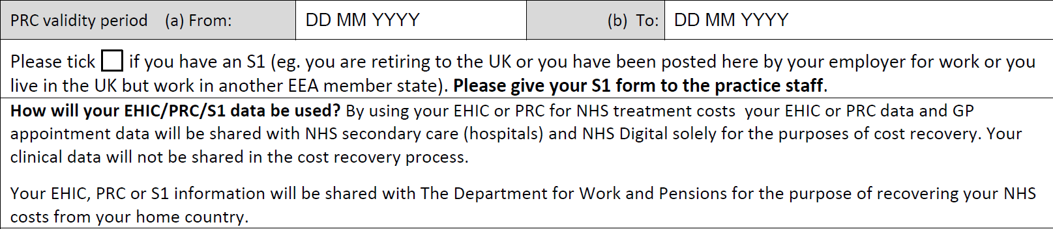

**Your Name**…………………………………….. **D.O.B**………………………………..

**CARER INFORMATION**

Do you act as a carer for anyone? YES/NO

If Yes: Name……………………………………………………….d.o.b………………………

Relationship to you…………………………………………………

Address………………………………………………………………………………………………………

Are they registering/ed with the Practice? YES/NO

If YES, please advise phone number for contact………………………………

Our Carers Lead will contact you re information & support in your area

Health Questionnaire **(Please fill in)**

Height(cm): Weight(Kg): Blood pressure:

Smoking:

**(Please fill in the relevant fields)**

Never smoked [ ] Ex smoker [ ] Smoker [ ]

Year stopped………………………Type smoked………………Amount (per day)………………

(I.e. Cigar/ Cigarette/ Pipe)

Smoking is associated with my chronic illnesses and puts you at an increased risk from high blood pressure, lung problems, cardiovascular disease, strokes, cancers and diabetes. Therefore we would advise all our patients to stop smoking.

Medical conditions: (i.e. Diabetes, Hypothyroidism and Cancer)

|  |
| --- |
| Condition: |
|  |
|  |
|  |
|  |

**Repeat Medications –** if you are on regular repeat medications it is **ESSENTIAL** you fill this in or attach your prescription B-side.

|  |
| --- |
|  |
|  |
|  |
|  |
|  |
|  |
|  |

Next of Kin………………………………. NoK Telephone Number………………………..

Relationship to patient…………………………………………………..

Family medical conditions: (i.e. Diabetes, Hypothyroidism and Cancer)

|  |  |
| --- | --- |
| Condition: | Relationship: (i.e. sibling, parent, child) |
|  |  |
|  |  |
|  |  |
|  |  |
|  |  |

Specific Needs:

|  |
| --- |
|  |

**Research**

Swanage Medical Practice takes part in a number of research programmes each year (please see attached leaflet). If you would prefer not to be contacted, please sign below:

Signature…………………………………………………………………….. Date………………...

Declined consent for researcher to access clinical record (XaX2F)

**Communication Needs (Xa4G3)**

Do you have any special communication needs? 🞏 Yes 🞏 No

🞏 Interpreter Needed (XaI8X)

🞏 Sign Language interpreter (XaLTC)

🞏 Large Print (XaPSp)

🞏 Communication via Text (Xabsc)

🞏 Braille Grade 1 (Xabsb)

🞏 Braille Grade 2 (Xabsa)

🞏 Requires communication verbally (XaPSq)

Other:

**Online Access**

By signing up for online access, once registered with us, you can book appointments, view your medical record, view test results and request repeat medication. You access this via the practice website: [**www.swanagemedical.org.uk**](http://www.swanagemedical.org.uk). Tick **Y** below and we will post you a unique password.

I would like to register for on-line appointment booking and prescription requests **Y / N**

**NEW Service – *E-Consult***

You can now consult with a Swanage GP online via the website homepage. A quicker, easier & more efficient way of dealing with your medical problems. You will receive a response within 48 hrs, often sooner, on working days.

**Electronic prescribing**

At this surgery patients receive their prescriptions electronically via a local pharmacy of their choice. Please complete the enclosed form indicating your choice of pharmacy.

**Patient Consent Form** *(it is important you fill out this section so we can contact you easily)*

I am happy for messages to be given as follows (Please tick as appropriate):

|  |  |  |
| --- | --- | --- |
|  | Non-clinical | Clinical |
| Next of Kin  If yes, name………………………………………  Relationship………………………………………. | Y / N | Y / N |
| Home answerphone | Y / N | Y / N |
| Mobile answerphone | Y / N | Y / N |

**Text Messaging**

**Consenting to text messaging means you will:**

Receive appointment reminders **\*** Have the ability to cancel appointments easily by text **\*** We can send relevant health information pertinent to you*We have the ability to contact you quickly when there is an important personal message for you from your GP.

**Y / N**

If you wish to **opt out** of text reminders, please tick the box [ ]

If you don’t tick the box we will assume they are happy to receive sms alerts from our practice.

**Your Electronic Patient Record & Sharing of Info**

In accordance with a locality agreement, we share your medical records with other services treating you. For full details, please see our patient leaflet, attached, or our website at [www.swanagemedical.org.uk/](http://www.swanagemedical.org.uk/)

Please be aware that we will automatically share your medical records with other services unless you wish to ‘opt out’. Please speak to a receptionist if this is the case.

Name……………………………………..Signature……………………..Date………………...

**For Patients aged 16 and over**



 **Total Score**

**I wish to decline the alcohol screening test**

**Swanage Medical Practice**

**Sharing your medical information**

**Background**

For a number of years, work has been ongoing to improve the way that medical records are made available to treating clinicians. As a result of this work we are now able to share clinical information between certain health professionals. This means that **with your consent**, we are able share your medical records with those in the NHS who are involved in your care. NHS staff can only access shared information if they are involved in your care and being an electronic service an audit log is maintained showing when and who has accessed medical records. This helps clinicians to make decisions based upon a wider knowledge of you and also helps to reduce the number of times that you or your family members are asked the same question. **In short it assists clinicians to provide more ‘joined up care’.**

We already share records of children for child protection reasons and patients who are under the care of the District Nursing Team.

**If I agreed, who could see my records?**

Clinicians treating you, who have access to the same system can **view** and in some cases **update** your medical records. Locally this includes the Walk-In-Centre, many departments at local hospitals (including A&E) and community services, such as the District Nursing Team. It is anticipated that over time more health services will be able use this system to access records if appropriate.

Clinicians outside of the surgery who wish to access your medical records will **ask for your permission** to do so and will need to have been issued with a NHS Smartcard. This is a ’chip and pin’ card -similar to a bank card.

**Can I choose who sees my record?**

Yes you can—there are two levels of consent. The first is to agree to sharing your medical records OUT of the practice. This is your agreement that records maintained by your GP can be seen, **subject to your authority at the time**, by clinicians working outside of the surgery. The second is agreeing to share your records IN. This means that your GP can see the records made by other health professionals who have access to EDSM.

However, as the treating clinician needs to ask your permission to see the records at the beginning of each period of care **you are in control of who can see your medical information**.

**What can I do if I don’t want to allow access to my records?**

As we feel this access will enhance patient care we will automatically ‘opt you in’ to both parts of the scheme.

**If you prefer not to be then please mention it to a member of the reception team.**

**You are free to change your mind at any time.**

**I can see the benefits of the other people treating me seeing my notes, but what if there is a matter that I want to stay just between me and my doctor?**

You can ask for any consultation to be marked as **private**, this means that viewing is restricted to the surgery, but allows the rest of the record to be viewed by whoever else is treating you. It is your responsibility to ask for a consultation to be marked as private.

**How is this different from previous arrangements?**

In the past other NHS Services see your current medications and the drugs that you are allergic or sensitive to via a **Summary Care Record.**

**Can I change my mind?**

**Yes,** you can always change your mind and amend who you consent to see your records. For instance you can decline to share your records out from the surgery, but if you built up a relationship with the physiotherapist who was treating you and they asked you if they could look at an x-ray report, you could give your consent at that point for them to view your records.

You will be referred back to us to change your preference, so the physiotherapist treating you should—with your permission—be able to see your records by the time of your next appointment.

**If I decline—what happens in an emergency?**

In the event of a medical emergency, for instance if you were taken unconscious to A+E, and the clinician treating you feels it is important to be able to see your medical records he is able to override any consents set.

However, the doctor has to give a written reason for doing so. Where this happens an audit is undertaken by the local Caldicott Guardian (the person with overall responsibility for Data Protection compliance).

**Can anyone else see my medical records?**

**Not unless you give your written consent for this to happen.**

On a daily basis, we get requests from Insurance Companies to either have copies of medical records or excerpts from patients’ medical records. This requires your signed consent as it has not been requested to treat/care for you.

Occasionally we are asked for information from the medical records for legal reasons, again this has to be done with your written consent, or in very exceptional circumstances, by court order.

**Any questions?**

If you have any questions, please speak to reception. If necessary the receptionist will arrange for another member of the team to give you a call.

**The Electronic Prescription Service (EPS)**

**The Electronic Prescription Service (EPS) is an NHS**

**Service that your GP uses to send your prescription to a pharmacy of your choice for**

**your medicines or appliance**

**What does this mean for you?**

From 21st March 2020 all prescriptions will be issued direct to the pharmacy of your choice. This means you don’t have to queue at your surgery and again at your pharmacy to collect your medication.

You will have more choice about where to get your medicines from because they can be collected from a pharmacy near to where you live, work or shop.

You may not have to wait as long at the pharmacy as there will be time for your repeat prescriptions to be made-up before you arrive. Most pharmacies are able to send you a text when your medications are ready for collection if you provide them with your mobile number.

**Is this service right for you?**

Yes, if you have a stable condition and you don’t want to go to your GP practice every time to collect your repeat prescription.

It may not be if you don’t get prescriptions very often or pick up your medicines from different places.

*Please note*: some medications are non-compliant with EPS, if this is the case you will be issued with a paper prescription.

**How can you use EPS?**

You need to choose a place for the practice to electronically send your prescription to. This is called *nomination.* You can choose a pharmacy or a dispensing appliance contractor (if you use one). To do this:

**It is ESSENTIAL you fill in the form below**.

.

**Can I change my nomination or cancel it and get a paper prescription?**

Yes but from 21st March 2020 you will be given a token with a barcode on it and not the actual prescription. The token can be given to any pharmacy who will scan the barcode to retrieve the prescription from the NHS Spine.

**Is EPS reliable, secure and confidential?**

Yes. Your electronic prescription will be seen by the same people in GP practices, pharmacies and NHS prescription payment and fraud agencies that see your paper prescription now.

**For more information about EPS visit www.cfh.nhs.uk/eps, your pharmacy or GP practice.**

***Source: Information taken from*** [***http://www.connectingforhealth.nhs.uk/systemsandservices/eps***](http://www.connectingforhealth.nhs.uk/systemsandservices/eps)

**Pharmacy Nomination Slip**

I would like to nominate: Boots, Station Road …..

(please tick accordingly)

Well (was Day Lewis), 40 Station Road …..

Well (was Co-op), 22 Station Road …..

Your Name………………………………………………………………………………………………….

Date of Birth………………………………………………………………………………………….

Signature……………………………………………………………………………………………..